BSc in Software Engineering with Professional Experience
School of Science, Engineering and Environment

Final Year Project Dissertation – 2025/2026

Project Title: Student Market Place with Price Prediction

Student Name: Israel Tamunokuro Karibo Alalibo
Student ID: @00677340
User ID: AGG526

Supervisors: Lee Griffiths and Maira Alamgir
2025-2026

Word Count: xxx

Abstract

Acknowledgements

Contents

Chapter 1: Introduction
Motivation:

Aim:

Objectives:

Adopted Approach:

Chapter 2: Literature Review

2.1 Introduction
The increasing emphasis on sustainability and affordability in higher education has prompted the development of peer-to-peer online marketplaces that enable students to exchange goods efficiently. Within universities, surplus educational resources (textbooks, electronics, and academic supplies) often remain underused or discarded, contributing to waste and avoidable expenditure (Bocken, Bakker & Pauw, 2016). E-commerce platforms can help mitigate this by supporting reuse and resale, thereby aligning with circular economy and cost-of-living objectives.
Recent research specifically examining student populations reveals distinct trading behaviours that general-purpose marketplaces fail to address. Wang et al. (2023) conducted a longitudinal study across five UK universities, demonstrating that students exhibit significantly higher price sensitivity (3.2x compared to general populations) and prefer geographically proximate transactions. Furthermore, Chen and Liu (2024) found that institutional affiliation serves as a more powerful trust signal for student traders than traditional reputation metrics, suggesting that campus-focused platforms require fundamentally different trust architectures than established marketplaces.
This literature review examines prior research and technologies relevant to the design of a web-based student marketplace with AI-driven price prediction, comparing similar applications and identifying gaps that this project addresses.

2.2 Lessons from Established Marketplaces: The Case of eBay
The success of eBay remains one of the most widely studied examples in e-commerce literature, providing valuable insights into how online marketplaces can foster trust, community, and sustained participation. At the core of eBay's success lies its reputation system, which enabled transactions among anonymous users by creating quantifiable trust signals. Empirical research demonstrates that sellers with strong feedback profiles consistently achieve higher sales and prices compared to new or poorly rated sellers (Resnick et al., 2006; Houser & Wooders, 2006).
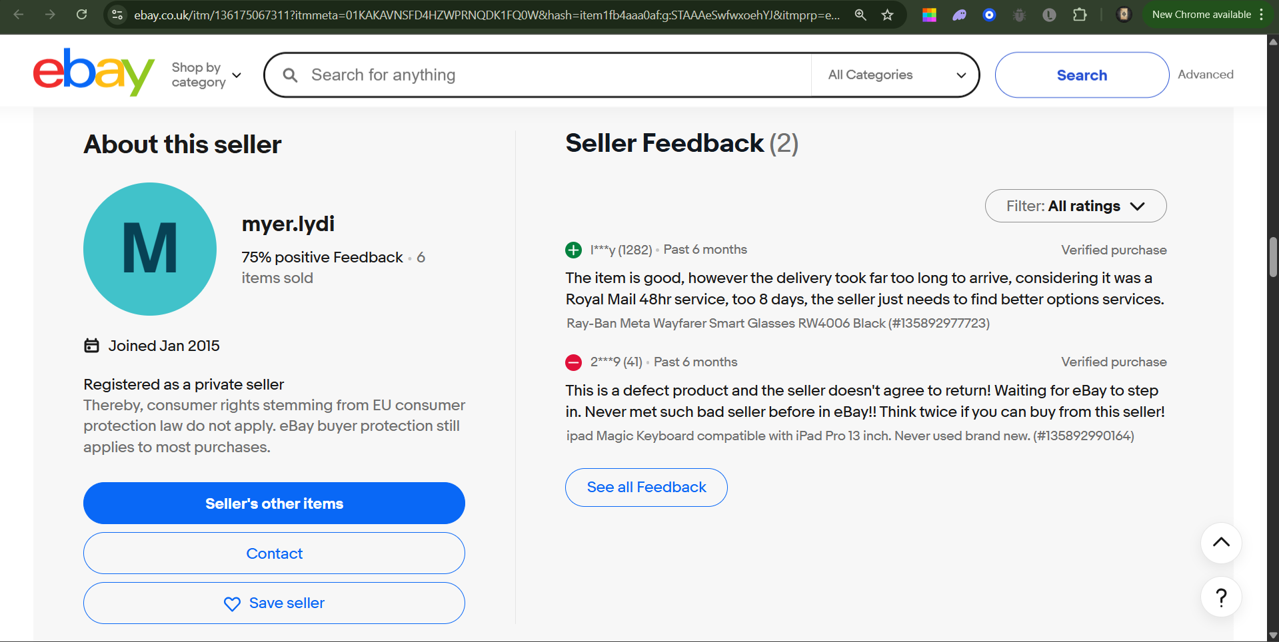
Figure 1: Feedback profile for random seller on eBay
Cabral and Hortaçsu (2010) found that negative feedback not only reduces immediate sales but also influences long-term seller exit, reinforcing the value of maintaining a positive reputation. This aligns with Baron (2001), who described eBay as a "community of traders" that relies on private ordering rather than external enforcement to sustain cooperation. Beyond trust, eBay cultivated transparency through peer regulation and communication tools (Dellarocas & Wood, 2004).
However, studies also identify ongoing challenges with price inconsistency, information overload on the platform, and trust management arising from user-driven pricing and unfiltered listings (Gavrilova & Kudryavtseva, 2019; Chen, Zhang & Xu, 2009). As illustrated in Figure 2, eBay's interface suffers from suboptimal information architecture with poor visual hierarchy for critical functions like sign-in.
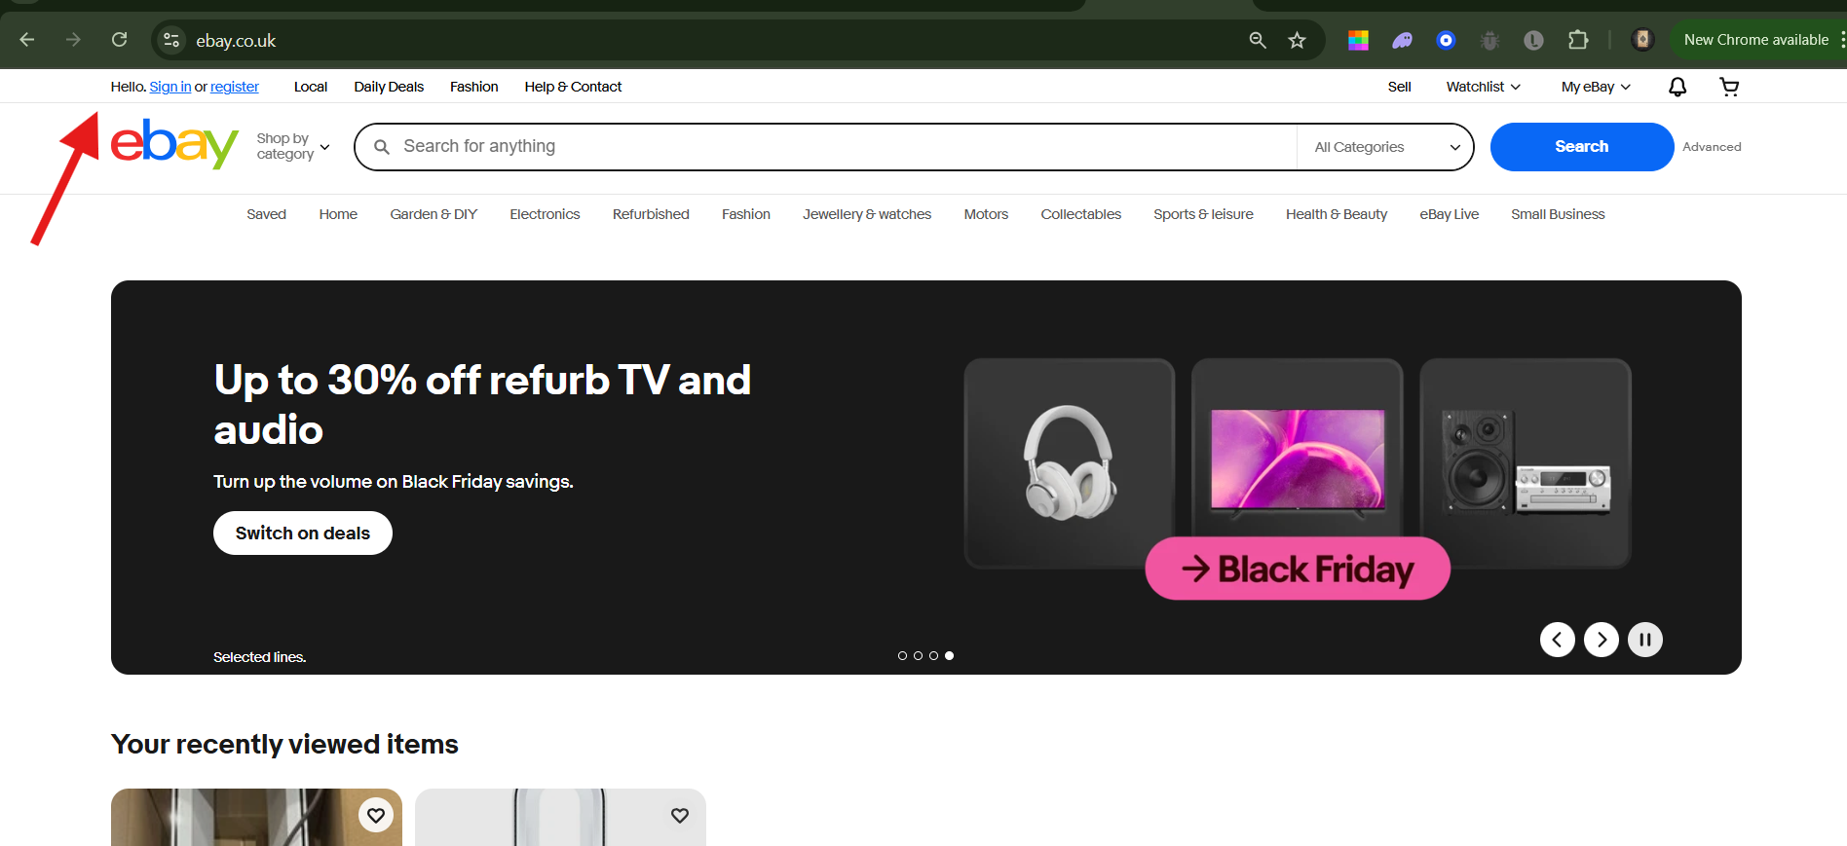
Figure 2: The placement and size of the Sign in/Register link (arrowed) on the eBay UK header, illustrating low visual weight
These combined factors - trust mechanisms, community identity, governance structures, and scale - form a composite model that subsequent e-commerce systems continue to replicate and refine.

2.3 Lessons from Contemporary Resale Platforms: The Case of Vinted
Vinted represents one of the most successful peer-to-peer resale marketplaces, integrating technological simplicity, sustainability values, and user trust to achieve large-scale adoption. Unlike traditional resale sites, Vinted's model eliminates seller fees, thereby reducing friction and attracting high participation across multiple European markets (Ellen MacArthur Foundation, 2021).
Its design emphasizes ease of use, mobile accessibility, and secure in-app payment features, which strengthen user engagement and retention (Balińska et al., 2024). Research indicates that Vinted's community-centric design has been particularly effective among Generation Z users, who associate the platform with both affordability and sustainable consumption (Balińska et al., 2024). According to Vinted's 2023 Impact Report, approximately 65% of users report that at least a quarter of their wardrobe consists of second-hand items, with each transaction preventing around 1.8 kg of CO₂-equivalent emissions (FashionUnited, 2024).
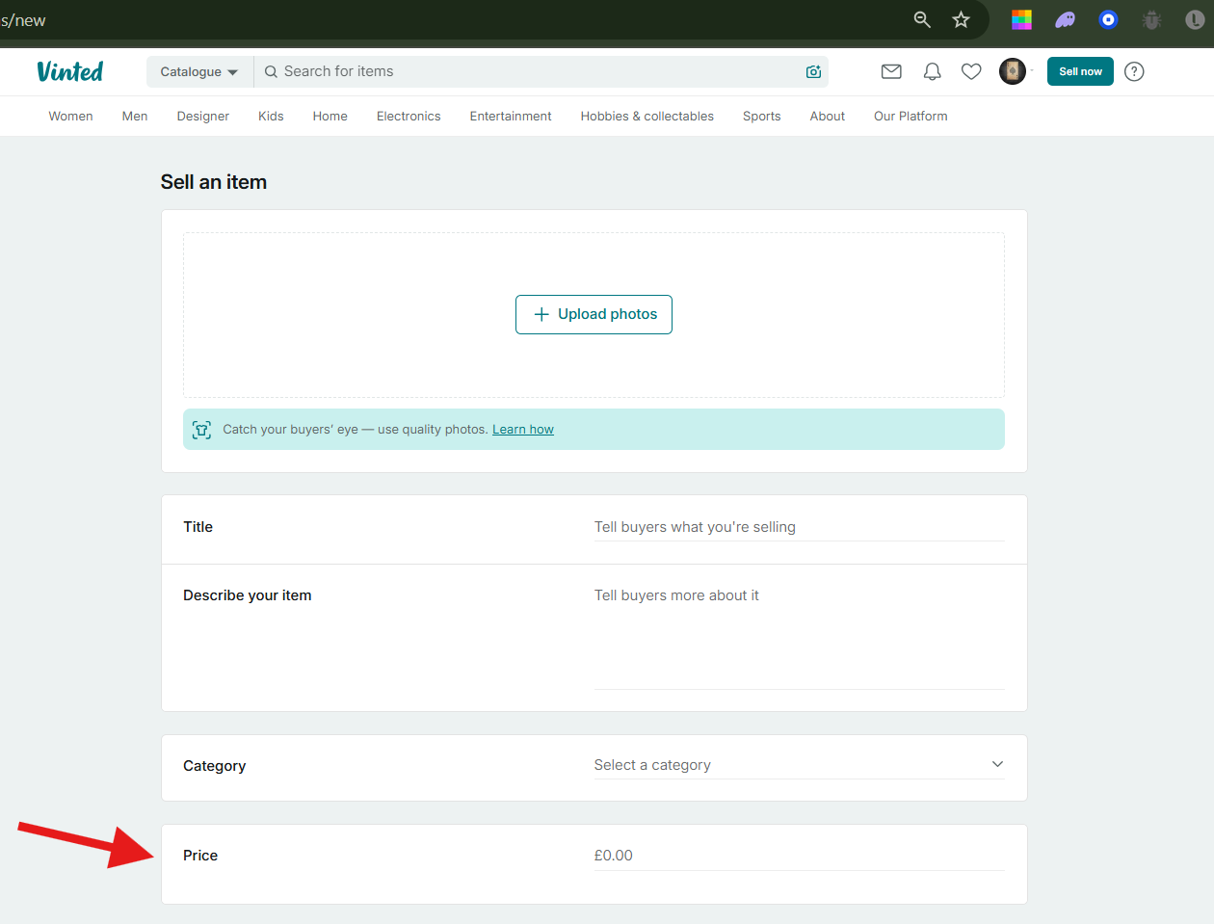
Figure 3: Illustration of heavy reliance on user-estimated pricing with Vinted
However, Vinted's sustainability-oriented resale model depends heavily on user-estimated prices, leading to valuation discrepancies and transaction uncertainty (Heller & Olsson, 2023; Balińska et al., 2024). This limitation provides a key opportunity for AI-enhanced pricing mechanisms.

2.4 Enhancing Existing Marketplace Models through AI Integration
The proposed student marketplace system builds upon insights from successful platforms such as eBay and Vinted, addressing key limitations through artificial intelligence integration to enhance pricing accuracy, user trust, and market efficiency.
Martinez and Thompson (2024) analysed over 50,000 second-hand textbook transactions, finding that machine learning price prediction models reduced price dispersion by 32% while improving transaction completion rates by 28%. Their work demonstrates that AI-assisted pricing not only enhances market efficiency but also increases user satisfaction by reducing the cognitive burden of price-setting decisions (particularly valuable for inexperienced student sellers).
To address shared limitations of existing platforms, the new system introduces an AI-based price prediction module capable of analysing historical sales data, product characteristics, and market trends to generate fair, data-driven pricing recommendations (Kaur, 2023; Carta et al., 2019; Fathalla, Salah & Ali, 2023). This predictive approach streamlines decision-making and enhances transparency within peer-to-peer transactions.
By merging eBay's dynamic trading model with Vinted's community-driven sustainability ethos, augmented by intelligent automation, the project aims to deliver a student-focused, AI-enhanced marketplace that improves pricing accuracy, reduces user bias, and promotes trust and engagement.

2.5 AI-Driven Price Prediction in E-Commerce Platforms
The use of machine-learning models for price prediction in e-commerce has gained notable traction, with research demonstrating meaningful improvements in prediction accuracy and user transparency. Kaur (2023) compares multiple regression-based and tree-based models (Random Forest, Multilayer Perceptron) for predicting product prices using attributes like category, discount, and payment method, finding potential for platforms to dynamically estimate selling prices.
Similarly, Carta et al. (2019) applied ARIMA models combined with Google Trends data to forecast online product prices, illustrating how temporal and demand signals enhance predictive power. In the domain of second-hand goods, Fathallah, Salah & Ali (2023) propose a dedicated price-prediction service for categorical e-commerce data, emphasising how ML algorithms deliver value in peer-to-peer marketplaces.
These studies collectively indicate that embedding AI-driven pricing tools can increase market efficiency, user trust, and pricing fairness. For the student marketplace project, integrating a price-prediction feature aligns with these findings by offering sellers and buyers real-time, data-driven valuations, thereby facilitating informed decisions, reducing listing friction, and enhancing platform credibility.

2.6 Research Gap and Project Justification
While established marketplaces such as eBay and contemporary platforms like Vinted have achieved considerable success, several critical gaps remain unaddressed, particularly within the student demographic and campus-based trading contexts.
Gap 1: Student-Specific Marketplace Needs – Existing research predominantly focuses on general consumer populations. Wang et al. (2023) highlight that university students exhibit distinct trading behaviours, including heightened price sensitivity, preference for local transactions, and episodic usage patterns aligned with academic calendars. Current platforms fail to address these needs: eBay's global scale introduces geographical friction, while Vinted's fashion-centric model neglects educational resources.
Gap 2: Algorithmic Price Discovery – Despite advances in AI-driven pricing within retail e-commerce, peer-to-peer marketplaces continue to rely predominantly on seller intuition. Martinez and Thompson (2024) demonstrate that ML models can reduce price dispersion and improve transaction completion, yet existing platforms have not integrated such capabilities.
Gap 3: Campus Sustainability Integration – Recent literature emphasises potential for campus-based marketplaces to support institutional sustainability goals (Kumar & Patel, 2023; Fernandez et al., 2024). Fernandez et al. found that 78% of students express willingness to participate in campus resale systems, yet only 19% currently do due to friction and trust concerns.
This project addresses these gaps through: (1) student-optimised platform architecture with institutional authentication and campus-specific features; (2) AI-enhanced price discovery reducing information asymmetry; and (3) explicit connection between digital infrastructure and circular economy objectives. By synthesising insights from established marketplace design, contemporary resale platforms, and emerging AI applications, this project delivers a theoretically grounded and practically viable solution to an underserved market segment.

Chapter 3: Methodology

3.1 Development Environment and Tools
The web application will be developed using a HP Pavilion laptop with 16GB RAM, Core i7 processor, and Intel Iris Graphics card, which is more than sufficient for the project's technical requirements. The code editor will be Visual Studio Code version 1.105.0, known for its flexibility and extensive extensions (Geekforgeeks, 2021). Testing will be conducted both locally via localhost and externally when hosted to a live web server using Vercel.

3.2 Evolution of Database Solutions and Backend Frameworks
In the early era of web development, websites overwhelmingly relied on relational database management systems (RDBMS), providing structured data, ACID transactional guarantees, and SQL as a standard query language (Praveen et al., 2017). However, as web applications scaled and data volumes exploded, limitations became apparent: horizontal scalability was difficult, schemas were rigid, and distributed architectures were challenging to implement (Schreiner et al., 2019).
In response, the NoSQL movement emerged, emphasising horizontal scalability, flexible data models, and distributed architectures (Băzăr & Iosif, 2014). More recently, database architecture evolved further with polyglot persistence, NewSQL systems, and cloud-based serverless backends where database management is increasingly abstracted from developers (Mester, 2025; Idreos et al., 2017).
The advent of Backend-as-a-Service (BaaS) platforms meant that developers could forgo managing database infrastructure, instead interfacing with managed services bundling database, authentication, storage, and real-time APIs (JIITAK blog, 2023). Supabase sits at the modern edge of this evolution: offering relational power plus developer convenience and modern features.
For backend frameworks, the comparative evaluation highlights varying strengths. While Django, Laravel, Ruby on Rails, and Spring Boot provide mature, structured environments with strong security and integrated tooling, their reliance on synchronous execution and heavier architectural patterns can restrict flexibility. Node.js stands out for its asynchronous, event-driven model supporting high concurrency and real-time interactions (Shetty et al., 2020; Madurapperuma et al., 2022). Supabase complements this by offering a scalable BaaS model with real-time PostgreSQL support and minimal configuration overhead.
Together, Node.js and Supabase provide an optimal balance of scalability, rapid development, and infrastructure efficiency, making them particularly well-suited for the proposed student marketplace platform.

3.3 Technical Architecture: Node.js and Supabase
The selection of Node.js as the backend framework is grounded in its scalability, asynchronous architecture, and extensive community support. Node.js operates on Google's V8 JavaScript engine and employs an event-driven, non-blocking I/O model, ensuring efficient handling of multiple concurrent client requests - ideal for platforms involving numerous simultaneous interactions such as product listings, purchases, and real-time messaging (Shetty, Hutagikar, & Hegde, 2020).
Unlike traditional synchronous frameworks such as Django or Laravel, Node.js supports microservice-based architectures and RESTful APIs that facilitate modular development and ease of maintenance (Madurapperuma, Shafana, & Sabani, 2022). Its single-language ecosystem, using JavaScript on both client and server sides, simplifies code reusability and accelerates development cycles - crucial for academic prototype projects (Nguyen, 2015).
The integration with Supabase, an open-source Backend-as-a-Service built on PostgreSQL, offers a highly complementary solution. Supabase provides real-time database capabilities, authentication, and API auto-generation, reducing extensive backend boilerplate code and server configuration. Node.js communicates efficiently with Supabase through REST or GraphQL endpoints, leveraging asynchronous processing for fast data retrieval and event updates (Orthian, 2024).

Advantages of Supabase:
- True relational database (PostgreSQL) retaining strong transactional support, complex queries, and full SQL semantics
- BaaS model saves time on infrastructure setup and operational overhead, supporting rapid development
- Built-in authentication, real-time capabilities, and storage align with modern web application expectations

Potential Limitations:
- Abstracted infrastructure control may limit fine-grained tuning for unusual distribution setups
- Potential vendor lock-in and cost scaling if project outgrows free/academic tier
This combination merges the speed and flexibility of JavaScript with the robustness of a managed relational database, creating a cohesive environment well-suited for modern web applications requiring real-time updates, minimal maintenance, and cost-efficient scalability.

3.4 Development Method: Agile-Scrum Implementation
The project adopts a design-and-implement methodology, underpinned by Agile-Scrum and iterative software engineering principles (Beck et al., 2001). This hybrid approach combines practical experimentation and theoretical grounding, enabling progressive refinement through sprints, reviews, and retrospectives. The methodology ensures flexibility, transparency, and continuous feedback during meetings with project supervisors, aligning with the Project Management Institute (PMI, 2021).
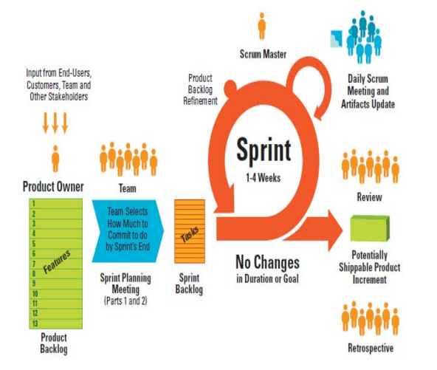
Figure 4: Scrum Process Overview (Khalil & Kotaiah, 2017)
The project utilises a two-week sprint cycle aligned with the academic calendar, comprising 12 sprints across both semesters. Each sprint focuses on incremental deliverables, with Agile selected over waterfall for its capacity to accommodate evolving technical requirements.

Key Sprint Milestones:
- Sprints 1-3 (Sept-Oct): Foundation, authentication, core listing functionality
- Sprints 4-6 (Nov-Dec): AI integration, user profiles, MVP refinement
- Sprints 7-9 (Jan-Feb): Messaging system, expanded AI prediction, review system
- Sprints 10-12 (Feb-Apr): User testing, refinement, final integration

Sprint Ceremonies:
- Sprint Planning (2 hours): Define user stories, prioritise backlog, estimate effort
- Daily Standups (15 minutes, self-conducted): Personal reflection documented in logbook
- Supervisor Check-ins (1-hour, mid-sprint): Progress demonstration, technical guidance
- Sprint Review (1 hour, end of sprint): Demonstrate working features, gather feedback
- Sprint Retrospective (30 minutes): Reflect on process improvements, document lessons learned
Risk Management: The sprint schedule accounts for key academic milestones, with buffer periods during heavy assessment weeks. Identified risks include API availability (mitigated through caching and alternative APIs), user recruitment challenges (early recruitment with incentives), and Supabase tier limitations (usage monitoring and upgrade budget).

3.5 Evaluation Methodology

3.5.1 Cooperative Evaluation Approach
The project employs cooperative evaluation, where users are treated as co-evaluators rather than experimental subjects (Carroll & Mack, 1984). This relaxed approach contrasts with traditional think-aloud protocols, allowing evaluators to pose questions and increasing the likelihood of accurately identifying key incidents through contextual understanding.

Participant Recruitment:
- Target Sample: 10-12 undergraduate students from University of Salford
- Recruitment: Email invitations, poster campaigns, social media promotion
- Inclusion Criteria: Currently enrolled students, 18+ years, basic computer literacy, prior online shopping experience
- Incentive: Entry into prize draw for £25 Amazon voucher

Testing Session Structure (60 minutes):
Phase | Duration | Activity | Data Collected
Introduction | 5 min | Consent, project overview, think-aloud explanation | Demographics, prior experience
Pre-task Questionnaire | 5 min | Background questions, expectations | Baseline attitudes toward marketplaces
Task Execution | 35 min | Guided task completion with think-aloud | Completion time, errors, verbal feedback
Post-task Questionnaire | 10 min | System Usability Scale (SUS), satisfaction ratings | Quantitative usability metrics
Semi-structured Interview | 5 min | Open-ended feedback, improvement suggestions | Qualitative insights, feature requests

Core User Tasks:
- Create account and complete profile setup (Target: <3 minutes)
- Create listing with AI price prediction (Target: <5 minutes)
- Search and filter items (Target: <2 minutes)
- Contact seller (Target: <1 minute)
- View and edit own listings (Target: <2 minutes)

3.5.2 Data Collection and Analysis
Qualitative Data: The evaluation will use records of what users say as they interact with the system rather than keystroke-level models, as the target student users will have baseline technical aptitude but not expert-level proficiency (Monk et al., 1991).

Quantitative Analysis:
- Task performance metrics (mean, median, standard deviation for completion times)
- Task success rate (binary: success/failure)
- Error counts per task
- System Usability Scale (SUS) scores (target: ≥70/100)
- AI price prediction acceptance rate

Qualitative Analysis:
- Think-aloud protocol transcription and thematic coding
- Critical incident technique identifying confusion points
- Affinity diagramming to cluster similar comments
- Generate actionable insights aligned with Nielsen's usability heuristics
Ethical Considerations: Compliance with UK GDPR and University of Salford research ethics policy. Informed consent obtained before testing, with participants assigned pseudonymous codes. Data stored on university-approved encrypted storage (One Drive), deleted 6 months post-submission. Screen recordings exclude personal information. Ethics approval obtained from School research ethics committee before participant recruitment.

3.6 Success Criteria and Project Evaluation Framework
To ensure rigorous assessment of project outcomes, measurable success criteria are established across functional, technical, and user experience dimensions.

3.6.1 Functional Success Criteria
Functional Area | MVP Requirement | Measurement Method
User Authentication | Email/password registration and login with Supabase Auth | Manual testing checklist; automated integration tests
Item Listing | Create listings with title, description, price, category, condition, image | Feature completion checklist; user task completion rate
Search & Discovery | Keyword search returning relevant results from database | Search result relevance scoring; user satisfaction rating
Transaction Management | Basic messaging between buyer and seller | Message delivery confirmation; transaction completion rate
AI Price Prediction | Price recommendation for books and electronics | Prediction accuracy (±15% of market value); API response time (<2s)

3.6.2 Technical Success Criteria

Performance Benchmarks:
- Page load time: <3 seconds on 3G connection (Lighthouse measurement)
- API response time: <500ms for standard queries, <2s for AI predictions
- Database query performance: <100ms for typical SELECT operations

Security Requirements:
- Row Level Security (RLS) implementation in Supabase
- HTTPS encryption for all data transmission
- Secure password hashing (bcrypt, minimum 10 rounds)
- Protection against SQL injection, XSS, CSRF vulnerabilities
- GDPR-compliant data handling

Code Quality:
- Minimum 60%-unit test coverage for critical functions
- Successful ESLint validation
- Documented API endpoints
- Meaningful commit messages and branch strategy

3.6.3 User Experience Success Criteria
Metric | Target | Measurement Method
Task completion rate | ≥85% for core tasks | Observation during user testing
User satisfaction (SUS) | ≥70/100 average | System Usability Scale questionnaire
Error rate | ≤10% errors per task | Logging of user errors
Learnability | ≥80% first-attempt success | First-time user observation

3.6.4 AI Model Performance Criteria
- Mean Absolute Percentage Error (MAPE): <15%
- Predictions within ±20% of actual market value: ≥80% of cases
- Validation: 20% holdout with K-fold cross-validation (k=5)

3.6.5 Evaluation Stages
Stage 1: MVP Evaluation (End Semester 1) – All core functional requirements implemented, 80% test cases passing, successful staging deployment
Stage 2: Beta Testing (Mid-Semester 2) – User testing with 10-12 participants, usability metrics meeting targets, critical bug documentation
Stage 3: Final Evaluation (End Semester 2) – All requirements completed, technical benchmarks achieved, comprehensive evaluation report, final deployment with documentation

3.7 Design Pattern
The project employs the Model-View-Controller (MVC) pattern. Given the iterative nature of development, the MVC pattern is ideal as the application's "look" can be drastically changed without modifying data structures and business logic (Leff et al., 2001). This pattern also leverages experience gained in second-year coursework where MVC was used extensively to develop a Parcel Tracking/Management System, allowing for more intuitive development and increased confidence with code management.
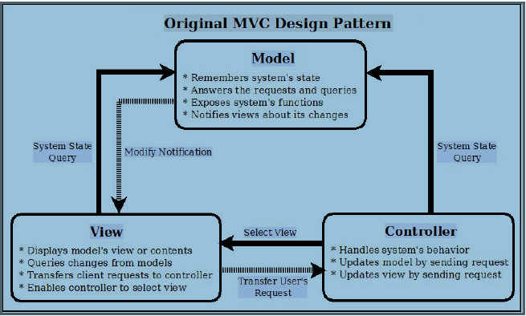
Figure 5: Model-View-Controller Design Pattern (Cortez & Vazhenin, 2013)

Chapter 4: Specification and Design

4.1 Introduction
This chapter presents the systematic approach taken to gather requirements and design the StudentHub e-commerce platform. The development followed an iterative methodology combining elements of Agile development with user centered design principles (Preece, Rogers & Sharp, 2015). The specification phase identified both functional and non-functional requirements through stakeholder analysis, while the design phase translated these requirements into a coherent system architecture using industry standard modelling techniques.

4.2 Requirements Engineering

4.2.1 Requirements gathering Methodology
Requirements were gathered through stakeholder analysis, use case modelling, and competitive analysis, then prioritised using MoSCoW methodology (Sommerville, 2016).
- Stakeholder Analysis: Identifying primary users (student as buyers/sellers)
- Use Case Analysis: Documenting user interactions with the system
- Competitive analysis: Examining existing platfoems (eBay, Facebook marketplace, Vinted) to identify essential features and improvement opportunities
- MoSCoW Prioritisation: categorizing requirements by importance (Must have, Should have, Could have, Won’t have)

Functional Requirements
The functional requirements define what the system must do (IEEE, 1998). Table 4.1 presents the core functional requirements identified for StudentHub.
ID | Requirement | Priority | Description
FR01 | User registration | Must | Users shall be able to create accounts using email and password
FR02 | User authentication | Must | Users shall be able to securely sign in and sign out
FR03 | Product Listing | Must | Sellers shall be able to list products with title, description, price, category, condition, and images
FR04 | Product Search | Must | Users shall be able to search products by keyword and filter by price range and category
FR05 | Shopping Cart | Must | Buyers shall be able to add, remove, and modify quantities of items in a persistent cart
FR06 | Secure Checkout | Must | The system shall process payments securely through Stripe payment gateway
FR07 | Messaging system | Should | Users shall be able to communicate with sellers through an in-app messaging system
FR08 | Order history | Should | Users shall be able to view their purchase history and order details
FR09 | Seller dashboard | Should | Sellers shall be able to manage their listings and view sales statistics
FR10 | Product Reviews | Should | Buyers shall be able to leave reviews and ratings for products
FR11 | AI Book Valuator | Must | The system shall provide AI-powered book valuation using ISBN lookup
FR12 | Email Notifications | Could | The system shall send confirmation emails to buyers and sellers upon transaction completion
FR13 | Profile Management | Should | Users shall be able to update their profile information and upload profile pictures
Table 4.1: Functional requirements

Non-Functional Requirements
Non-functional requirements specify the quality attributes and constraints of the system (Chung et al., 2000). Table 4.2 documents these requirements:
ID | Category | Requirement | Metric
NFR01 | Performance | Page Load time | < 3 seconds on standard broadband
NFR02 | Performance | API response time | < 500ms for 95% or request
NFR03 | Scalability | Concurrent users | Support minimum of 100 simultaneous users
NFR04 | Security | Data encryption | All sensitive data encrypted using TLS 1.3
NFR05 | Security | Authentication | Secure session management with JWT tokens
NFR06 | Security | Payment security | PCI-DSS compliance through Stripe
NFR07 | Usability | Accessibility | WCAG 2.1 Level AA compliance
NFR08 | Usability | Mobile responsiveness | Fully functional on devices ≥320px width
NFR09 | Reliability | Uptime | 99.5% availability
NFR10 | Maintainability | Code documentation and loose coupling | All components should minimally impact other components when modified, all API endpoints documented as well.
Table 4.2: Non-Functional Requirements
    - Use Case Modelling
Use case diagrams provide a high level view of system functionality from the users perspective (Cockburn, 2001). Figure 4.2.4 illustrates the primary use cases for StudentHub.
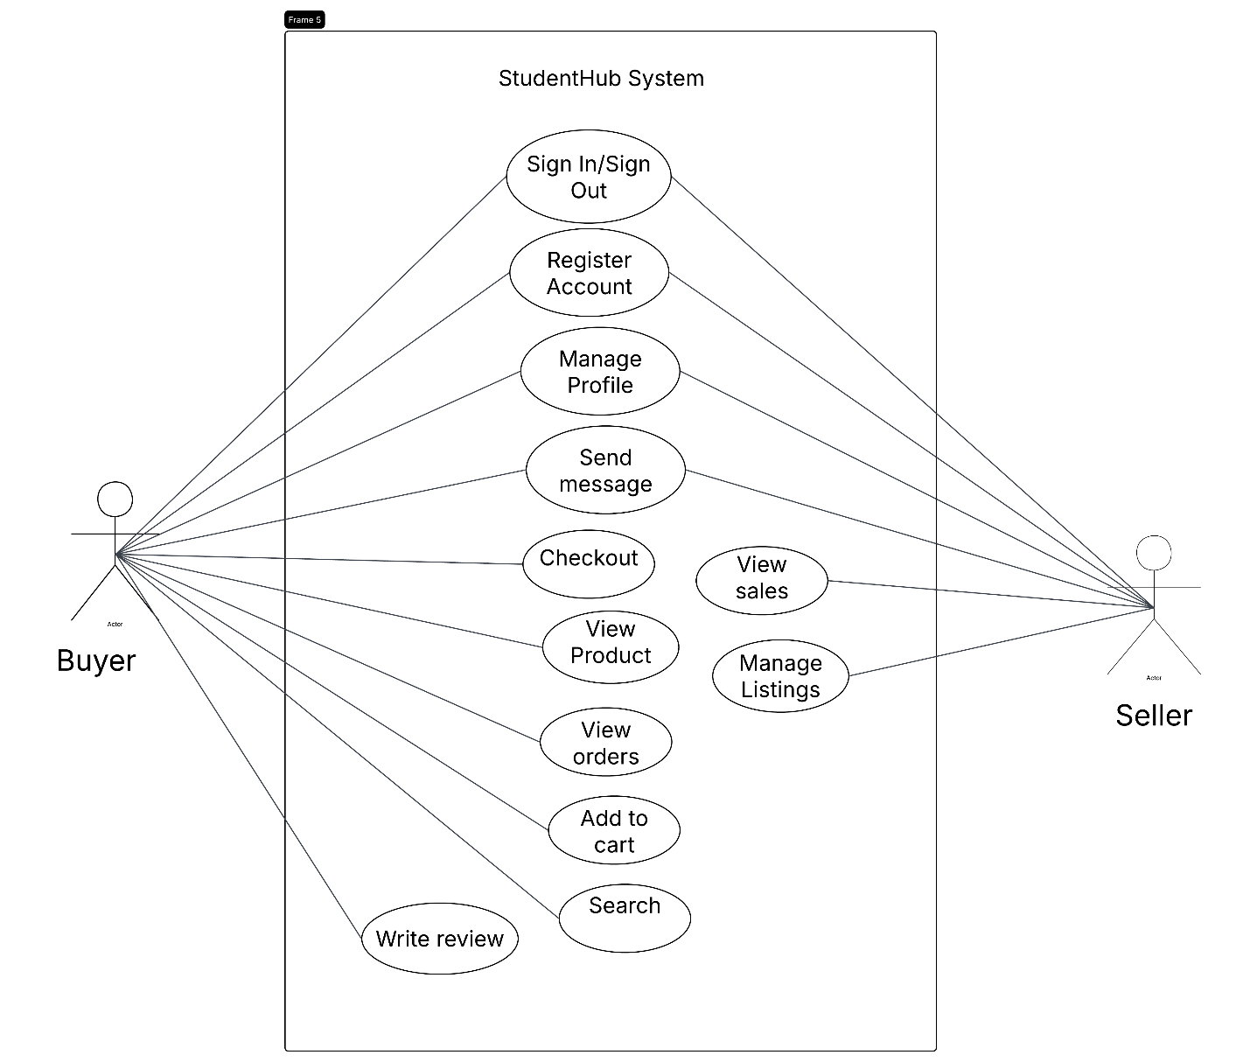
Figure 4.2.4: Use Case Diagram

    - User Stories
Following Agile methodology, requirements were also captured as user stories (Cohn, 2004). Key user stories include:
Authentication
- “As a student, I want to create an account so that I can buy and sell items on the platform”
- “As a registered user, I want to securely log in so my account”
Buying
- "As a buyer, I want to search for products by name so that I can quickly find what I need.”
- "As a buyer, I want to filter products by price range so that I can find items within my budget."
- "As a buyer, I want to add items to my cart so that I can purchase multiple items at once."
- "As a buyer, I want to pay securely with my card so that my financial information is protected."
Selling
- "As a seller, I want to list my items with photos so that buyers can see what I'm selling."
- "As a seller, I want to receive notifications when my items sell so that I can arrange delivery."
- "As a seller, I want to see my earnings so that I can track my sales performance."
Communication
- “As a user, I want to message sellers directly so that I can ask questions about products”

4.3 System Architecture Design

4.3.1 Architectural Pattern Selection
The system architecture follows a three-tier client-server model (Eckerson, 1995), separating concerns into:
- Presentation Tier – Client-side HTML, CSS, Javascript
- Application Tier – Node.js/Express.js server handling business logic
- Data Tier – Supabase (PostgreSQL) database
This architecture was selected for several reasons:
- Separation of concerns: each tier can be developed, tested, and scaled independently (Martin, 2017). This in accordance with the overall project plan of following an incremental approach (AGILE) to develop the solution
- Maintainability: Changes to one tier minimally impacts others. This directly supports NFR10 (see section 4.2.3) which emphasises on maintainability of the system as a whole.
- Scalability: Tiers can be scaled horizontally as demand increases. Given that every year there is a hug inflow of student enrolment at the University as highlighted in the literature review, there is a need to cater to this by making the application as scalable as possible to handle the potential traffic.
- Security: Database is never directly exposed to clients. By delegating the database infrastructure to a third party like Supabase, not only does this shield the database from the users it also …
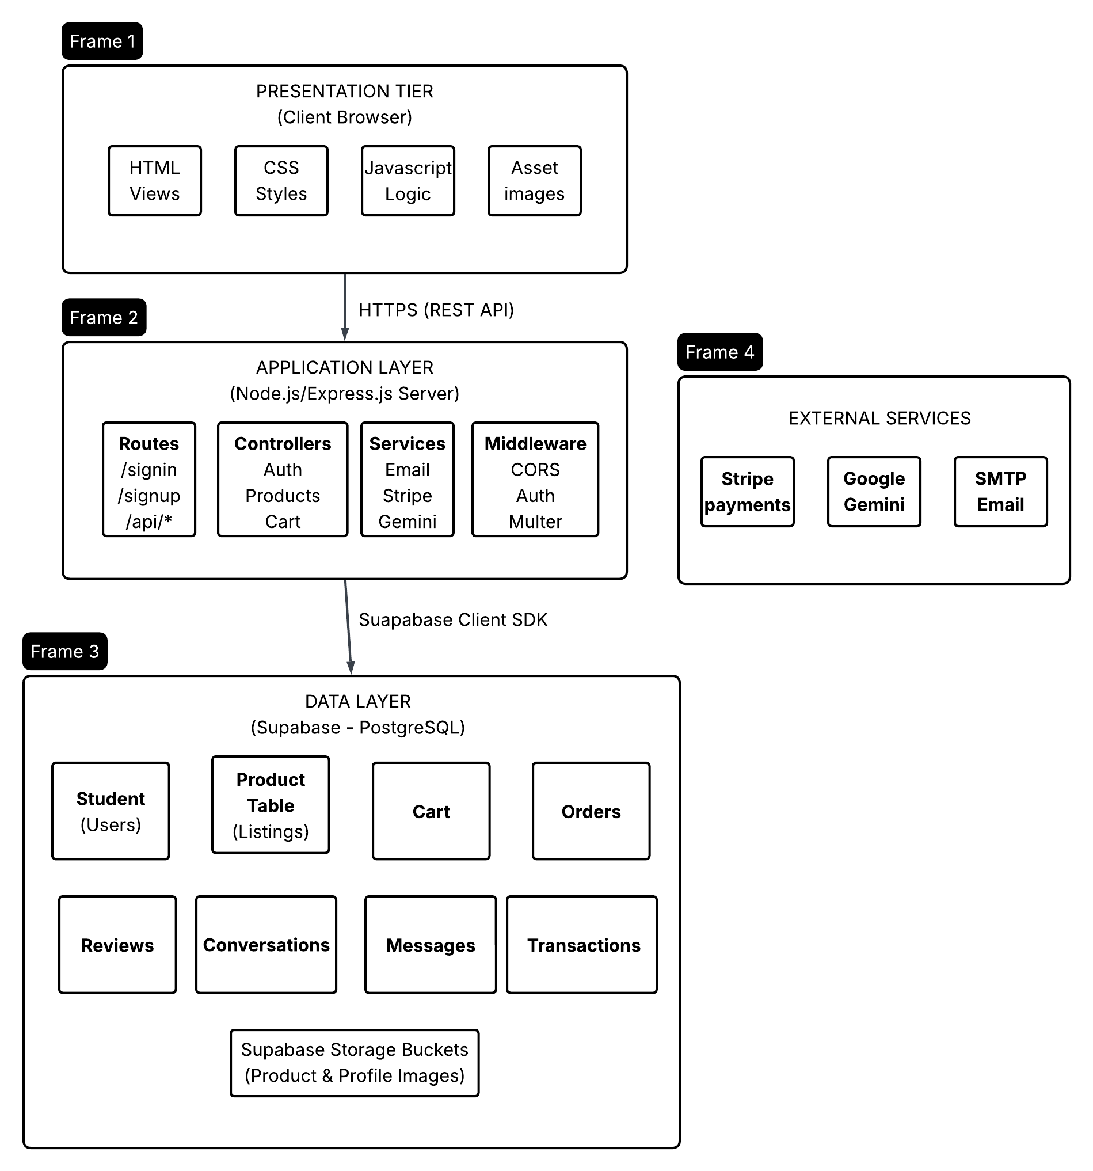
Figure 4.3.1: Three Tier Architecture Diagram

4.3.2 Technology Stack Rationale
Component | Technology | Justification
Frontend | HTML5, CSS3, JavaScript (ES6+) | Universal browser support; no build tooling required; rapid development (Mozilla, 2023). This is very key for the nature of this project given there will be different users of the applications and tney will have different browser preferences.
Backend | Node.js with Express.js | Event-driven architecture ideal for I/O-bound operations; large npm ecosystem; JavaScript consistency across stack (Tilkov & Vinoski, 2010).
Database | Supabase (PostgreSQL) | Open-source; built-in authentication; real-time capabilities; row-level security; generous free tier for student projects.
Payments | Stripe | Industry-leading security (PCI-DSS Level 1); extensive documentation; test mode for development; handles complex payment flows. As student data is involved while using this application, Stripe makes a perfect candidate for the payment system as they already do a great job at following the Data Protections Act
AI Integration | Google Gemini API | State-of-the-art language model; generous free tier for students compared to other altenatives such as Claude and ChatGPT; structured JSON output support
File Storage | Supabase Storage | Integrated with database; CDN delivery; access control policies
Email | Nodemailer with SMTP | Flexible; supports multiple providers; well-documented

RESTful API Design
The API follows REST architectural principles (Fielding, 2000), using standard HTTP methods and meaningful resources URIs. Table 4.3.3 documents the core API endpoints
Method | Endpoint | Description | Authentication
POST | ‘/signin’ | User authentication | Public
POST | ‘/ignup’ | User registration | Public
POST | ‘/logout’ | End user session | Required
GET | ‘/search’ | Search product by keyword | Public
GET | ‘/search/category’ | Filter products by keyword | Public
GET | ‘/api/featured-products’ | Get featured products | Public
GET | ‘/api/cart’
Table 4.3.3: API Endpoint Design

4.4 Database Design
4.4.1 Entity-Relationship Model
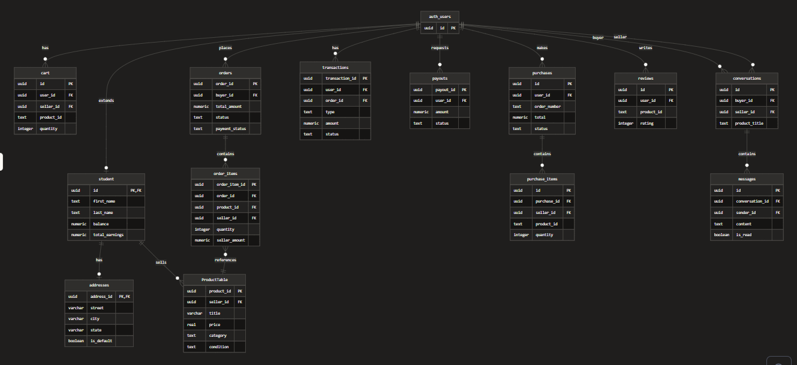
The database design follows normalisation principles to Third Normal Form (3NF) to eliminate data redundancy and ensure data integrity (Codd, 1970). Figure 8 presents the Entity-Relationship diagram.
Figure 4.4.1: Database Schema

4.4.2 Table Schemas
Table | Primary Key | Foreign Keys | Purpose
student | id(UUID) | auth.users(id) | Stores user profile information
ProductTable | product_id | Seller_id -> students(id) | Product listings
Cart | id | User_id, product_id | Shopping cart items
Orders | order_id | buyer_id -> student (id) | Purchase orders
Order_items | order_item_id | order_id, product_id, seller_id | Individual order line items
Conversations | Id | buyer_id, seller_id | Message threads
Messages | Id | conversation_id, sender_id | Individual message
transactions | transaction_id | User_id, order_id | Payment records
purchases | id | user_id | Purchase history
purchase_items | id | purchase_id | Purchase line items
Table 4.4.2: Database Scheme Specifications

4.4.3 Data Integrity Constraints
The database implements several integrity mechanisms:
- Primary Key: UUID generation (automatically done by Supabase) ensures global unique identifiers
- Foreign Keys: Referential integrity with CASCADE delete where appropriate
- Row Level Security (RLS): Supabase policies restrict data access by user
- Check Constraints: Price must be positive, rating for a product must be between 1-5
- Not Null Constraints: Required fields enforced at database level

User Interface Design

4.5.1 Design Principles
The UI design follows the establishment of usability heuristics (Nielson, 1994):
- Visibility of System Status: Loading indicators, success and error messages
- Match between System and Real world: Familiar e-commerce conventions as inspired by Vinted and eBay
- User control and Freedom: Easy navigation, undo capabilities
- Consistency and standards: Uniform styling and predictable interactions
- Error prevention: Form needing user inputs are validated before submission and actions that may lead to a change to the application data are followed by confirmation dialog boxes
- Recognition rather than Recall: Clear and easy to read label used as well as visible option
- Flexibility and Efficiency: Search, filter and quick actions have been implemented to allow for more optimized use of the platform
- Aesthetic and minimalist Design: Clean UI layout as well as focused content

4.5.2 Information Architecture
The site structure follows a hub-and-spoke model centred on the landing page (Rosenfeld & Morville, 2002)

4.5.3 Wireframes
A wireframe is a basic blueprint that illustrates the core form and function found on a screen of a webpage or application (Matthew, 2026). Wireframes are very useful to measure the effectiveness of a webpage against the usability requirements. Low fidelity wireframes were created to establish the layout and content hierarchy before visual design (Garrett, 2011).
Both the mobile and desktop wireframes were fully hand-drawn and designed to capture the core webpages the user would usually interact with.
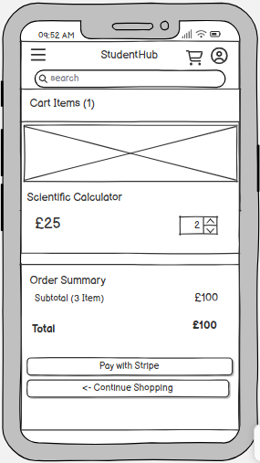
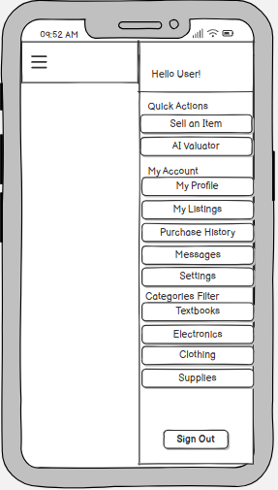
Mobile Wireframes
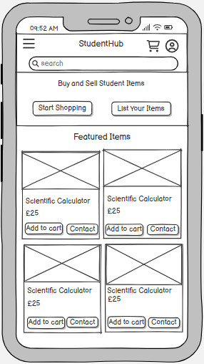

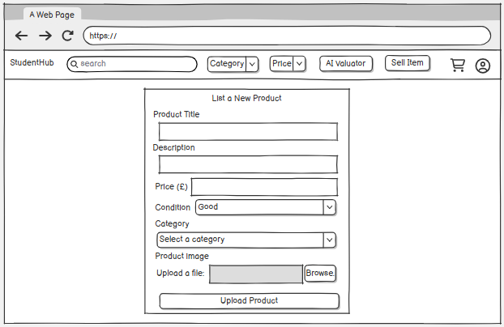
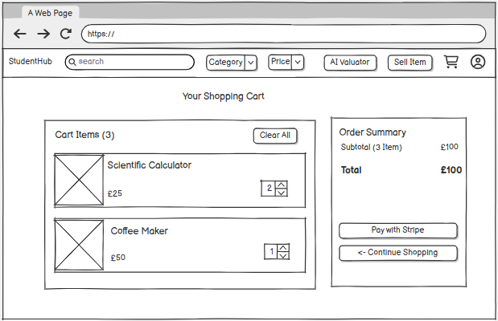
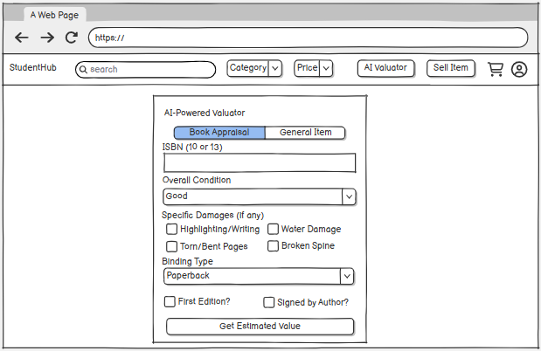
Desktop Wireframes
Figure 2: Desktop AI Valuator Page
Figure 3: Desktop List Item Page
Figure 4: Desktop Cart/Checkout Page
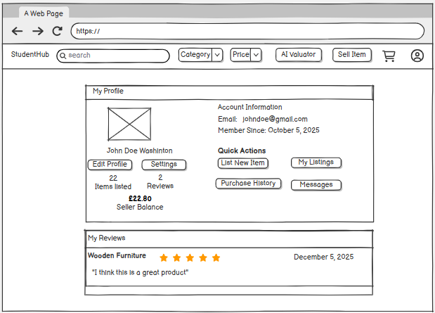
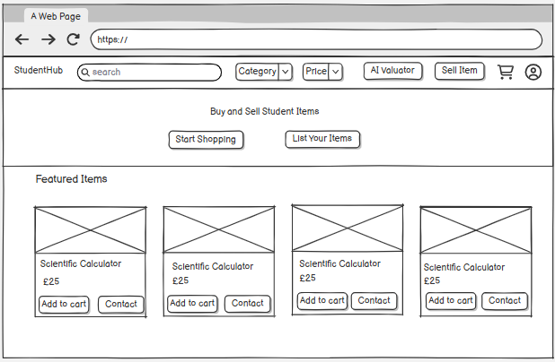
Figure 5: Desktop My Profile Page
Figure 1: Desktop Landing Page

Security Design
Security Design for StudentHub is driven by the need to protect student users’ identities and payment data, enforce access to listings and messages, and satisfy the non-functional security requirements (NFR04 – NFR06). The following subsections describe how each security layer is applied within the system, why it is appropriate for a student marketplace context, and what alternatives were considered.
Authentication and Authorisation: StudentHub must reliably identify users so that only a liting’s seller can edit or remove it, only a buyer can see their own cart and orders, and only participants in a conversation can view the messages (FR03, FR05, FR07, NFR05). The system implements a multi-layered approach as follows, with explicit benefit to StudentHub:

- Password Security: All passwords for the users will be hashed using bcrypt via the in-built Supabase Auth rather than stored in plain text or with a weak scheme. The benefit of this is that if the database were ever exposed, student credentials remain protected. Supabase is highly suitable for this as Supabase Auth provides this out of the box, avoiding custom crypto implementation and reducing risk or error.
The alternative considered was implementing bcrypt in the application tier but this was rejected as it would duplicate logic and require secure secrete management; delegating to Supabase keeps one source of truth for password handling.

- Session Management: JWT tokens will be used to handle the session across the system with automatic refresh (access and refresh tokens issued by Supabase). The benefit of this to StudentHub is that user stay signed in across page loads and API calls without re-entering credentials, which is essential for cart persistence (FR05) and a smooth checkout flow (FR06).
Stateless JWT tokens stood out to be the most suitable technology for StudentHub as it fits a deployment where the same app may run on multiple instances (e.g. Poseidon, Vercel) without server-side session store.
The alternative considered was server-side sessions but this would require additional infrastructure and configuration; for the expected scale and deployment environments of StudentHub, JWTs were deemed sufficient and simpler to operate.

- API Protection: Every protected endpoint (Cart, orders, messaging, listings management) validates the session on the server, typically by resolving the current user via Supabase Auth, before performing any data operation. The key benefit of this to the project Is that unauthorised access is prevented even if the client is tempered with (e,g a user attempting to access another user’s orders by guessing IDs)
This approach is suitable as Express server acts as the single point where “who is this user?” is answered, aligning with the three-tier design and NFR05. No alternative was preferred; Server-side validation is mandatory for a secure design.

- Row Level Security: Database policies in Supabase restrict data access by user ID (e.g students see only their own profile, cart rows and conversation they participated in). The key benefit of this approach to StudentHub is that even if a bug or future change exposed a query without proper server-side checks, RLS provides a second barrier so that users cannot read or modify other users data.
This approach is suitable as PostgreSQL RLS is well-supported in Supabase and fits the model where every sensitive table is scoped by ‘user_id’ or equivalent. Relying solely on application-tier checks was the alternative considered but was rejected this would mean potentially more bugs whereas RLS adds minimal overhead for the project’s data volume.
Payment Security: StudentHub processes card payment at checkout (FR06) and must comply with NFR06 (payment security) without handling processes card data. The system delegates handling to stripe. The following point describe how this benefit StudentHub and why it is suitable for the project:
- Payment Card Industry Data Security Standard (PCI-DSS) compliance: Card details never reach StudentHub server; they are entered on Stripe’s hosted Checkout page. This is particularly good for StudentHub is that the platform avoids the scope of PCI-DSS for card holders’ data, which would otherwise require stringent infrastructure and auditing.
This approach is suitable because for a student project and a university-hosted deployment, achieving PCI-DSS in-house would be impractical; delegating to Stripe is the standard approach for small-to-medium e-commerce.

The only alternative option was storing and processing card data on the application backend which was never really an option due to compliance and risk issues; the only real choice was which provider (Stripe was chosen for documentation, test mode and wide spread use)

- Tokenisation and HTTPS: Stripe replaces sensitive data with tokens and all communications use HTTPS. This is particularly beneficial for the project as the application only ever handles session URLs, payment IDs and webhook payloads, no card numbers or CVV. Combined with TLS (NFR04), data in transit is protected. This is also suitable with the project’s constraint of not operating payment card infrastructure

- Webhook Verification: Stripe webhooks are verified using a signed secret so that the server only processes events that genuinely originated genuinely originated from Stripe. The key benefit of this to the platform is that it prevents an attacker from sending fake “payment successful” requests to the application and marking orders as paid without real payment. This is essential for correct order and balance state (FR06, FR09); verification is implemented in the checkout/verify-payment flow. No alternative was considered for production; unverified webhooks would be insecure

Input Validation: StudentHub accepts user input in many forms: sign-up and sign-in credentials, product titles and descriptions, cart quantities, messages, and profile updates (FR01–FR03, FR07, FR13). Unvalidated or unsensitized input could lead to injections, broken layouts, or stored malicious content. The system applies validation at three levels, each with a clear role in this system:
- Client-side (HTML5 and JavaScript): Required fields, email format, and numeric ranges are validated in the browser. This is beneficial as users get immediate feedback and fewer invalid requests reach the server, improving usability (NFR07) and reducing unnecessary load. This approach is suitable for the project as it fits the chosen UI approach (server-rendered pages with client-side enhancements) and requires no extra framework. Relying only on client-side validation was rejected because it can be bypassed, it is used as a convenience layer, not as a security boundary.

- Server-side (Express): All API and form handlers validate and sanitise inputs (e.g. trimming strings, checking types and lengths, rejecting obviously malicious payloads). This ensures that only well-formed data is passed to Supabase and that abuse (e.g. oversized messages or invalid prices) is rejected before affecting the database. In term of suitability, the Express layer is the correct place to enforce business rules and input limits for a three-tier architecture. This is the main line of defense for input safety.

- Database (Constraints): Supabase/PostgreSQL schemas enforce NOT NULL, unique constraints, foreign keys, and value ranges (e.g. rating 1–5). For StudentHub, this guarantees data integrity even if a bug or future change omits server-side checks, supporting NFR10 (maintainability) and correct reporting (e.g. seller dashboard, FR09). This is suitable for the project as normalised design and constraints are already part of the data model (Section 3.5); using them for validation is consistent and adds defense-in-depth. No alternative was preferred; database constraints are standard practice for integrity.

Design Decisions and Trade-Offs
The following subsections document key design decisions for StudentHub. Each is framed In terms of howthe decision affects the systems, why it is suitable for the project context and what alternatives were considered and why they were accepted or rejected.

Server-Side Rendering Vs Single Page Application
Decision: StudentHub uses traditional server-rendered HTML pages with Client-side JavaScript for form submission, cart updates and API calls rather than a full Single page Application (SPA) framework such as React or Vue.
Benefit to StudentHub: (1) Product listing and search pages are delivered as full HTML, which improves initial load and makes product URLs directly shareable and indexable (important for a marketplace where students may share links to items (FR04, FR03). (2) The architecture avoids build tooling, routing and state management inherent in SPAs, so the codebase stays manageable for a single developer and for future maintenance (NFR10). (3) Tye same Express server that serves pages also hosts the REST API (cart, checkout, messaging), keeping one deployment unit and consistent authentication (NFR05)
Suitability for Project: The project scope (MoSCoW requirements in Table 4.1) does not demand highly dynamic, app-like interactions on every screen; most flows are form based or list-and-detail. Server-rendered pages with targeted client-side enhancements are sufficient and reduce the risk of scope creep and framework-specific bugs during the dissertation timeline.
Alternative Considered: A full SPA (e.g. React front end calling the same backend) would allow richer interactivity (e.g live search without full page reload) but would require separate front-end build, deployment, and CORS/Session handling. Given time constraints and the need to prioritise core commerce and security (FR01 - FR06, NFR04 - NFR06), the SPA option was rejected in favour of a simpler, single-codebase approach. The trade-off, less dynamic interactivity than a React/Vue SPA, was accepted as acceptable for the stated requirements and user stories.

Backend-as-a-service (Supabase) Vs. Custom Backend
Decision: StudentHub uses Supabase as the backend for the relational database (PostgreSQL) and for authentication (sign-up, sign-in, session, password reset), rather than a custom backend (e.g. self-hosted PostgreSQL plus hand-built auth and REST API only).
Benefit to StudentHub: (1) Supabase provides a managed PostgreSQL instance with a RESTful API and Row Level Security, so the system can enforce per-user data access (Section 3.7.1) without operating database servers. (2) Built-in authentication (bcrypt, JWT, refresh tokens) directly satisfies FR01, FR02, and NFR05 and integrates with the same database, keeping user identity consistent across auth and application data (e.g. `student.id` linked to Supabase Auth). (3) Development time is reduced because schema design, migrations, and auth flows are implemented against Supabase’s APIs and dashboard rather than from scratch. (4) The free tier is sufficient for a dissertation-scale deployment (e.g. Vercel, Poseidon) and for demonstration and assessment.
Suitability for Project: As a student project with a fixed delivery timeline, investing in a custom auth implementation and database hosting would divert effort from requirements that add more value to the dissertation (e.g. checkout, AI Valuator, reviews, messaging). Supabase’s PostgreSQL foundation also supports the normalized schema and integrity constraints described in Section 3.5, so the choice is consistent with the data design.
Alternative Considered: (1) Custom backend with self-hosted PostgreSQL and custom auth: rejected due to development and operational overhead and security risk of implementing auth incorrectly. (2) Other BaaS (e.g. Firebase): considered; Supabase was chosen for SQL and RLS, which align with the relational design and the need for complex queries (search, joins for cart and orders). The trade-off—vendor lock-in and limited low-level customisation—was accepted because portability was less critical than delivering a working, secure system within the project scope.

Integrated Vs. Third Party Payments
Decision: StudentHub integrates the Stripe payment platform for checkout (FR06) rather than implementing an in-house payment flow or using a different provider
Benefit to StudentHub: (1) Card data never touches the application or database, so the system meets NFR06 (payment security) and avoids PCI-DSS scope for cardholder data. (2) Stripe Checkout Sessions handle the redirect flow, payment confirmation, and webhook events; the application focuses on creating sessions (cart → order → session URL) and verifying payment to update order status and clear the cart (Section 3.7.2). (3) Test mode allows full development and demonstration without real charges. (4) Documentation and ecosystem support reduce integration risk and debugging time, which is important for a time-limited project.

Suitability for project: The functional requirement FR06 (“process payments securely through Stripe”) and NFR06 explicitly assume a third-party gateway. Implementing payments in-house would be out of scope and unsafe. Among third-party options, Stripe is widely used, well-documented, and offers a clear model (Checkout Session + webhook) that fits the existing flow: create order, send user to Stripe, on return verify and complete order. The platform fee (e.g. 5%) and Stripe’s transaction fees (e.g. 2.9% + 30p) are a known trade-off for the project; they are not customisable at the application level and were accepted in exchange for security and compliance.
Alternatives considered: (1) In-house card handling: rejected on security and compliance grounds. (2) Other gateways (e.g. PayPal, Braintree): could satisfy FR06 and NFR06; Stripe was chosen for consistency with common teaching material, strong documentation, and Checkout Session abstraction that matches the desired user flow. The trade-off-transaction fees and dependency on Stripe’s API and policies was deemed acceptable for a student marketplace where the primary goal is to demonstrate a secure, end-to-end payment flow rather than to minimise cost.

Summary
This chapter has presented a comprehensive specification and design for SudentHub e-commerce platform. The requirement phase identified 13 functional requirements and 10 non-functional requirements through systematic stakeholder analysis and use case modelling. The system architecture follows a three-tier model, with technology choices justified based on technical merit and project constraints.
The database design implements normalised schemas with appropriate integrity constraints, while the UI design follows established heuristics, Security considerations are addressed through a multi-layer approach including JWT Session management, Row Level Security and payment security through Stripe integration.
The security and design decisions are framed with explicit rationale, reflects careful consideration of trade-offs between development speed, maintainability, and functionality appropriate for a student marketplace application, StudentHub. Each choice is justified in terms of how it benefits the system, why it is suitable for the project context, and what alternatives were considered.

Chapter 5: Development and Implementation

5.1 Introduction
This chapter describes how the StudentHub e-commerce platform specified in chapter 4 was implemented to meet the identified functional and non-functional requirements. The work was organised into three development sprints (increments), each delivering a coherent set of features aligned to specific requirements and user stories. The narrative is structured as a development journey, it shows how the application evolved from a minimal viable product, through engagement and trust-building features, to implementing supervisor feedback, to enhancements and production hardening (Sommerville, 2016). For each sprint, the chapter outlines the requirements in scope, the implementation approach using appropriate data structures and design techniques, the main problems encountered and solutions adopted, and how the outcome was verified. A consolidated treatment of data structures and algorithms used across sprints is provided, followed by a summary that ties the three increments to the full requirement set.

5.2 Development Approach and Environment

5.2.1 Methodology and Sprint Structure
Development followed an iterative, sprint-based approach consistent with Agile practice (Cohn, 2004). Each sprint was treated as an increment: a vertical slice of the system that could be demonstrated and tested end-to-end, from front-end views through the application tier to the database. Priority was driven by the MOSCOW Classification from the specification:
Sprint | Requirement
1 | Must Haves (FR01 – FR06, FR11)
2 | Should Have (FR07 – FR10, FR13)
3 | Must Have (FR12), Could Have (FR12), deployment reliability and performance validation (NF03, NFR09, NFR10)
Table 5.2.1: Sprint Table

The AI Book Valuator was classified as Must have because not only is it a key feature of the project but it provides essential differentiation for a student marketplace where textbooks are a common listed item and supports sellers in pricing fairly. This ordering ensured that the risk of the project delivering no working product was minimised, as a usable marketplace existed from the end of Sprint 1, before the AI Valuator and deployment hardening were added in Sprint 3.

Technology Stack and Tooling
The technology stack matched the design documented in Chapter 3. The application tier was implemented in Node.js (v
<Continue?????>

Sprint 1: Foundation and Core Commerce (MVP)

The first sprint aimed to deliver a minimal viable product: a student should be able to register an account, sign in securely, list items with photographs, search and filter the product catalogue, add items to a persistent shopping cart, and complete a purchase via secure card payment. This scope was chosen because it represents the irreducible core of a marketplace — the system has no value to buyers or sellers unless these six capabilities are present and function correctly together.

5.3.1 Implementation
Authentication (FR01, FR02): Registration was implemented as a `POST /signup` endpoint. The Supabase Admin API was used to create the user in Supabase Auth, and a corresponding row was simultaneously inserted into the `student` table using the same UUID as the primary key. This approach was selected because it preserves referential integrity with the entity–relationship design established in Chapter 3: all application-level records that reference a user can use a single stable identifier, which reduces join complexity and eliminates the need for a separate mapping table (Codd, 1970). Sign-in (`POST /signin`) was implemented using `signInWithPassword`; on success, the server returned the user identifier and session tokens (access and refresh) to the client. For protected routes, the client either supplied tokens via an `Authorization` header or used `POST /api/restore-session` to allow the server to restore the Supabase session and resolve the current user via `supabase.auth.getUser()`. Protected endpoints consistently checked for an authenticated user and returned HTTP 401 in its absence, ensuring that unauthenticated access to user-specific data was not possible (NFR05).
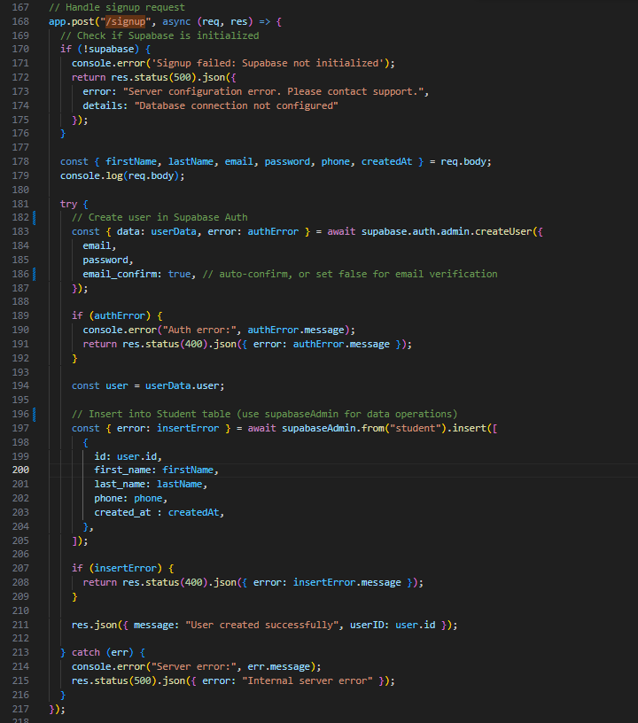
Figure 1: 'POST /signup' Implementation
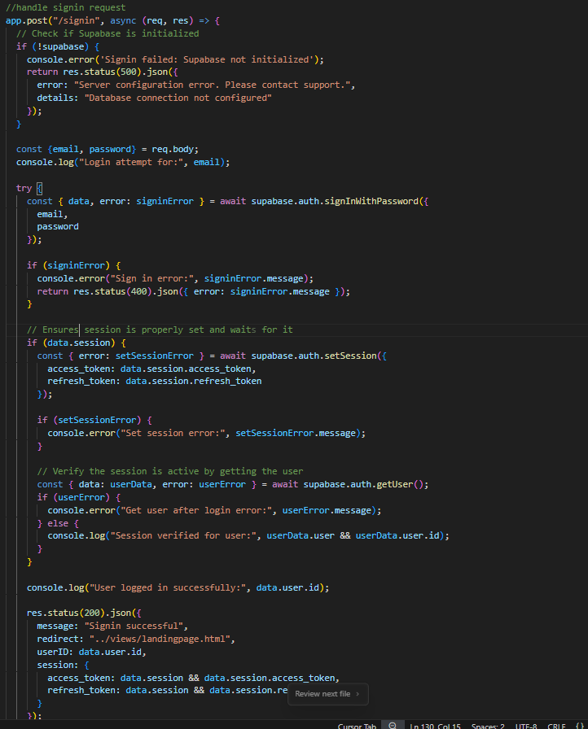
Figure 2: 'POST /signin' Implementation

Product listing (FR03): The`POST /uploadProduct` handler was implemented to accept multipart form data including title, description, price, category, condition, and an image file. The image was validated for type and size, written to a temporary path (using a serverless-safe directory, as discussed in Section 3.2), uploaded to Supabase Storage under a path keyed by `{seller_id}/{timestamp}.{ext}`, and the resulting public URL is persisted alongside the product record. This pattern — uploading to object storage and storing only the URL in the relational database — was selected because it avoids storing binary data in PostgreSQL, which would have increased egress costs and reduced query performance; object storage is better suited to serving large, infrequently-changing binary assets (NFR02, NFR03). The product row was inserted into `ProductTable` with the `seller_id` resolved from the authenticated session, ensuring that only the authenticated seller could create listings under their identity.
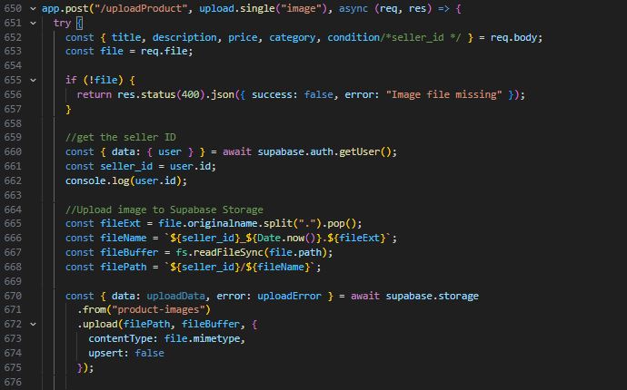
Figure 3: 'POST /uploadProduct' Implementation
Search (FR04): Two search surfaces were implemented to serve different usage patterns. The primary keyword and category search (`GET /search`, `GET /search/category`) applied `ilike` on `title` and `description` for case-insensitive substring matching, with optional category and price-range predicates using `.gte()` for products greater than or equal to the set price and `.lte()`for products less than or equal to the set `price`.
Results were enriched with seller names joined from the `student` table. A lighter endpoint, `GET /api/products/search`, was implemented to support live or autocomplete-style search: it enforced a minimum query length to avoid trivially large result sets and applied a configurable result limit, reducing database egress and supporting the response-time requirement (NFR02).
The decision to implement two distinct endpoints, rather than a single general-purpose search, was made because the usage profiles differ in result size, query frequency, and front-end rendering requirements, and a unified endpoint would have required additional conditional logic that would reduce clarity without adding correctness.
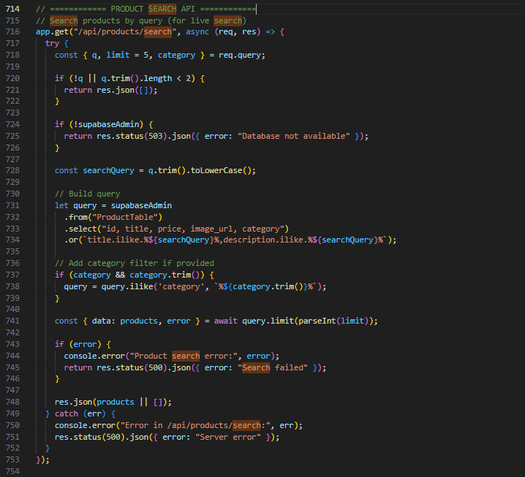
Figure 4: 'GET /search' Implementation

Shopping cart (FR05): The cart was implemented as a persistent store in the `cart` table, with a composite logical key of `(user_id, product_id)`. This design was chosen over a client-side cart (e.g. browser `localStorage`) because client-side storage does not persist across devices or sessions, which would be a significant usability limitation for a student marketplace (NFR07). The add-to-cart operation (`POST /api/cart`) performed a read-then-write: if a row for `(user_id, product_id)` already existed, the quantity was incremented; otherwise a new row was inserted with quantity 1.
Denormalised fields (title, price, image URL, category, condition, seller ID, and seller name) were stored in the cart row to simplify cart display and checkout without requiring joins at read time; the trade-off is that these fields could become stale if a listing is updated, which was accepted as a reasonable simplification for the project scope.
Update, delete, and clear operations were all scoped by `user_id` to ensure that users could only modify their own carts.
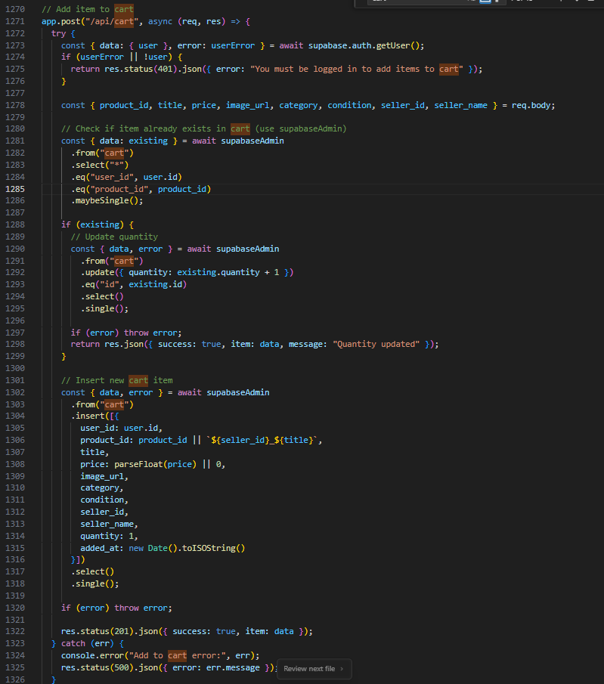
Figure 5: 'POST /api/cart' Implementation

Checkout and payment (FR06, NFR06): A two-phase checkout flow was implemented to separate the concerns of session creation and payment verification. In Phase 1 (`POST /api/checkout/create-session`), the server resolved each cart item to a product row in `ProductTable`, validated that the authenticated buyer was not attempting to purchase their own listing (a constraint required for marketplace integrity), computed a subtotal and a platform fee, created an `orders` row with status `pending` and corresponding `order_items` rows, called `stripe.checkout.sessions.create()` with the appropriate line items and success/cancel URLs, and returned the Stripe-hosted checkout URL to the client. This approach was selected because it ensures that order records exist before the user leaves the application for Stripe, making subsequent verification straightforward.
In Phase 2 (`POST /api/checkout/verify-payment`), the server retrieved the Stripe session by ID, confirmed that `payment_status === 'paid'`, updated the order status to `paid`, credited sellers via `transactions` rows, cleared the buyer's cart, and created `purchases` and `purchase_items` records for order history. Delegating card data handling to Stripe's hosted page ensured that the application server was never exposed to raw card details, satisfying NFR06 and avoiding the need for PCI-DSS compliance at the infrastructure level.

<Add image>????

5.3.1 Problems Encountered and Solutions
Session and data client separation: During initial development, a single Supabase client instance was used for both authentication and data operations. This caused session state to affect data queries: after sign-out or session expiry, data operations returned 401 errors or used an incorrect user context.
The issue arose because the Supabase client maintains session state internally, and mixing authentication and data operations through a single instance made this state difficult to control. The solution adopted was to introduce two separate client instances — `supabaseAuth` for all authentication operations and `supabaseAdmin` for all database queries — so that their session states were fully independent. This separation is discussed further in Section 4.7.1.

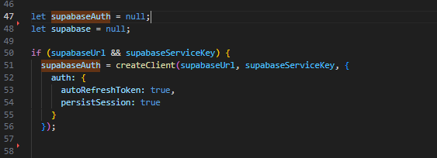
Figure 7: Previous Approach
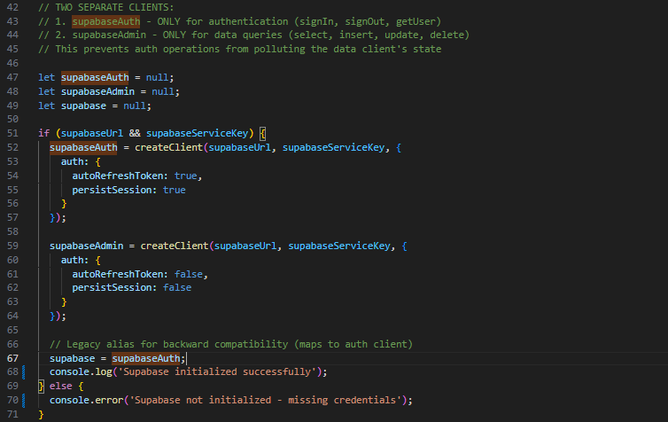
Figure 8: Solution for Overlapping authentication and Data queries logic

References
- Wireframing Essentials. (2026). Google Books. https://books.google.co.uk/books?hl=en&lr=&id=GhyxAgAAQBAJ&oi=fnd&pg=PT5&dq=wireframes+web&ots=ezd8ggkKX_&sig=1HJkNSZjDajeb-V6wcd_1w3YXVU&redir_esc=y#v=onepage&q=wireframes%20web&f=false
- Booch, G., Rumbaugh, J. and Jacobson, I. (1999) *The Unified Modeling Language User Guide*. Reading, MA: Addison-Wesley.
- Chung, L., Nixon, B.A., Yu, E. and Mylopoulos, J. (2000) *Non-Functional Requirements in Software Engineering*. Boston: Kluwer Academic Publishers.
- Cockburn, A. (2001) *Writing Effective Use Cases*. Boston: Addison-Wesley.
- Codd, E.F. (1970) 'A Relational Model of Data for Large Shared Data Banks', *Communications of the ACM*, 13(6), pp. 377-387.
- Cohn, M. (2004) *User Stories Applied: For Agile Software Development*. Boston: Addison-Wesley.
- Eckerson, W.W. (1995) 'Three Tier Client/Server Architecture: Achieving Scalability, Performance, and Efficiency in Client Server Applications', *Open Information Systems*, 10(1), pp. 3-20.
- Fielding, R.T. (2000) *Architectural Styles and the Design of Network-based Software Architectures*. PhD thesis. University of California, Irvine.
- Garrett, J.J. (2011) *The Elements of User Experience: User-Centered Design for the Web and Beyond*. 2nd edn. Berkeley: New Riders.
- IEEE (1998) *IEEE Recommended Practice for Software Requirements Specifications*. IEEE Std 830-1998.
- Martin, R.C. (2017) *Clean Architecture: A Craftsman's Guide to Software Structure and Design*. Boston: Prentice Hall.
- Mozilla (2023) *MDN Web Docs*. Available at: https://developer.mozilla.org (Accessed: 27 January 2026).
- Nielsen, J. (1994) 'Enhancing the Explanatory Power of Usability Heuristics', *Proceedings of the SIGCHI Conference on Human Factors in Computing Systems*, pp. 152-158.
- Preece, J., Rogers, Y. and Sharp, H. (2015) *Interaction Design: Beyond Human-Computer Interaction*. 4th edn. Chichester: Wiley.
- Rosenfeld, L. and Morville, P. (2002) *Information Architecture for the World Wide Web*. 2nd edn. Sebastopol: O'Reilly Media.
- Sommerville, I. (2016) *Software Engineering*. 10th edn. Harlow: Pearson Education.
- Tilkov, S. and Vinoski, S. (2010) 'Node.js: Using JavaScript to Build High-Performance Network Programs', *IEEE Internet Computing*, 14(6), pp. 80-83.

